

**ENGLISH COMPONENT – CYCLE 4 SESSION 5**

**THE TWILIO PROGRAMMABLE VIDEO PLATAFORM**

**WORKSHEET 4.5**

**Worksheet 4.5.1**

**Vocabulary**

Write down a synonym, definition or translation for each word below.

* Cloud : nube
* Credentials: certificates-credenciales-instruction letters
* Server: servidor-the main computer
* Subscribe: suscribirse
* Render: renderizar/presentar
* Join: union-unirse-unir
* One-to-one: uno a uno

**Worksheet 4.5.2**

**Vocabulary practice**

**Read carefully the sentences and choose the best option to complete them.**

1. **If you want to … our online class, you need to ask the teacher for Zoom link.**
2. Join.
3. Render.
4. **I prefer to store my photos in a … storage instead of a memory card.**
5. Server.
6. Cloud.
7. **I prefer … classes instead of group sessions because I can get all the attention of the teacher.**
8. One-to-one.
9. In-person.
10. **If you want to learn English words, … to our channel and watch our weekly videos with new vocabulary.**
11. Join.
12. Subscribe.
13. **All data is stored in the central file …**
14. Server.
15. Credentials.
16. **The security guard checks the … of all the personnel that enter the bank.**
17. Authenticators.
18. Credentials.
19. **Money serves as a reward for the services that you … .**
20. Joined.
21. Rendered.

**Worksheet 4.5.3**

**Reading**

Read the following text and use the information to complete the steps of all graphic organizers

**The Twilio Programmable Video Platform**

Twilio Programmable Video is a **cloud** platform that allows developers to add video and audio chat to Web, Android and iOS applications. The platform provides different tools that make it simple to capture, distribute, record, and render high quality audio, video, and screen shares.

**Part 1:** [**Twilio Video Applications**](https://www.twilio.com/docs/video/tutorials/basic-concepts#twilio-video-applications)

A Twilio Video Application is an application that uses the Twilio Programmable Video platform. To create a Twilio Video Application you need three ingredients:

1. Your Twilio Account: Opening a Twilio Account is [free](https://www.twilio.com/try-twilio). Once you have a Twilio Account you will get the **credentials** to use all Twilio’s Services.
2. Your **server** application: The server application runs at your application server. It uses your Twilio Account credentials to grant access to Twilio Video services.
3. Your client application: The client application executes at a web or mobile client. It can capture, publish, **subscribe** and **render** the RTC (Real Time Communication) information.

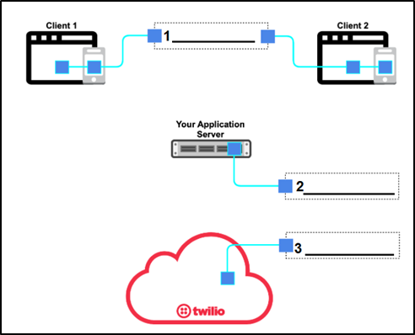

**1. Your Server Application**

**2. Your server application**

**3. Your Twilio Account**

**How Twilio Video Applications Work**

This section illustrates what happens in a simple one-to-one Twilio Video Application.

**Part 2: Create a Room**

First, your server application tells Twilio to create a Room using the Rooms REST API. Second, Twilio validates the provided API credentials and creates the Room. Twilio will monitor the Room state until it is completed. Finally, Twilio returns the Room information to your application. This includes the Room SID: a unique identifier that can be used in future API requests to refer to this Room.

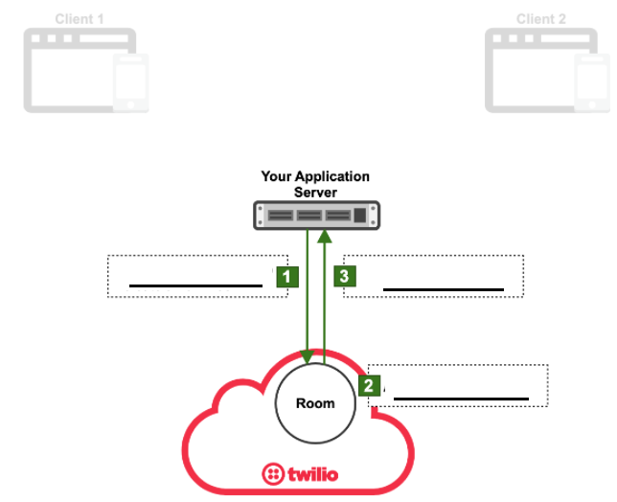

**1. App tells Twilio to create a new Room**

**2. A New Room is created**

**3. Twilio answers proving the Room SID**

At this point, the Room is still empty.

**Part 3: Client 1 gets an Access Token**

Clients need to obtain an Access Token to connect to a Room. This guarantees that your application has full control of who is authorized to **join** the Room.

First of all, Client 1 requests an Access Token from your Application Server. Second, your Application Server uses your Twilio account credentials to generate a cryptographically **secure** Access Token. Finally, the Access Token is returned to Client 1.

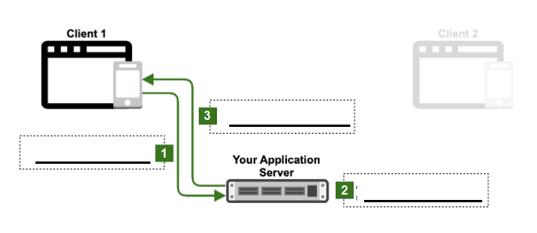

**1. Client requests access Token.**

**2. Access Token generated using Twilio’s credentials.**

**3. Access Token returned to client.**

**Part 4: Client 1 connects to the Room**

First, Client 1 connects to the Room and authenticates using the Access Token that he received. Second, Twilio verifies the Access Token. If it is valid, a signaling connection gets established between the client and the Room.

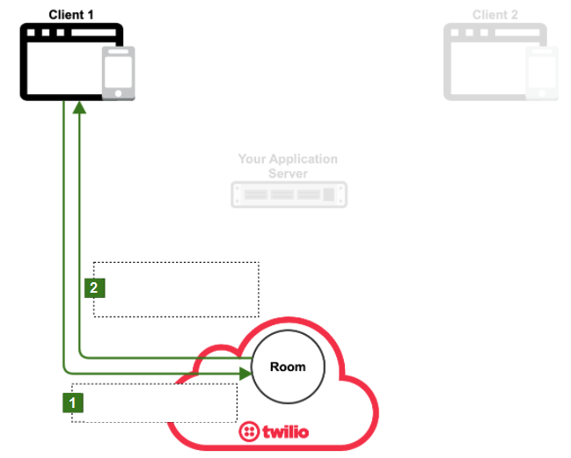

**1. Participants connect to Room using access Token**

**2. Twilio checks access Token. Connection established.**

At this point, the client becomes a Participant in the Room and can publish and/or subscribe to media tracks from other Participants.

**Part 5: Client 2 connects to the Room**

Other clients can connect to the Room. The process for Client 2 to connect to the Room is the same. First of all, Client 2 requests an Access Token. Second, Twilio generates an Access Token using the credentials. After that, the Access Token is returned to Client 2. Next, Client 2 uses the Access Token to connect to the Room. Finally, Twilio accepts the Access Token and a signaling connection gets established.

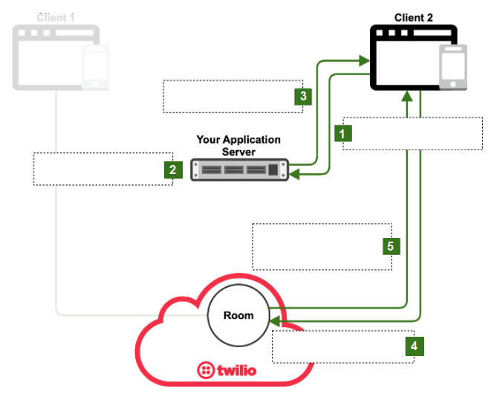

**1. Client requests access Token.**

**2. Access token generated using Twilio credentials.**

**3. Access token returned to client.**

**4. Participants connect to room using access token.**

**5. Twilio accepts access token. Connection established.**

Client 2 is now a Participant of the Room.

**Part 6: Media tracks are published and subscribed**

A Room Participant can publish audio, video, and data Tracks to the Room. In this case, Client 1 publishes a Track named T1. After that, the rest of the Room Participants are notified of this Track publication and can subscribe to T1. In this case, Client 2 subscribes to T1. Then, additional Participants can publish or subscribe to Tracks. In this case, Client 2 publishes a Track named T2, which is then subscribed by Client 1.

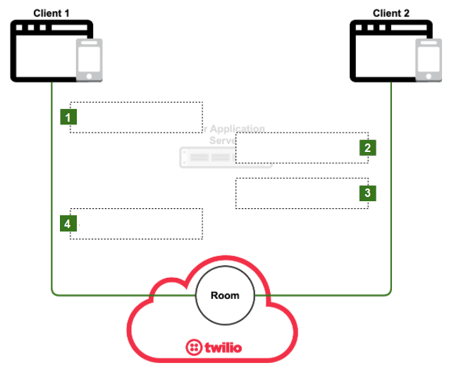 **1. Publishes T1**

**2. Subscribes T1**

**3. Publishes T2**

**4. Subscribes T2**

**Worksheet 4.5.4**

**Wrap-up**

Share your graphic organizers with the group and then compare them to the right answers.

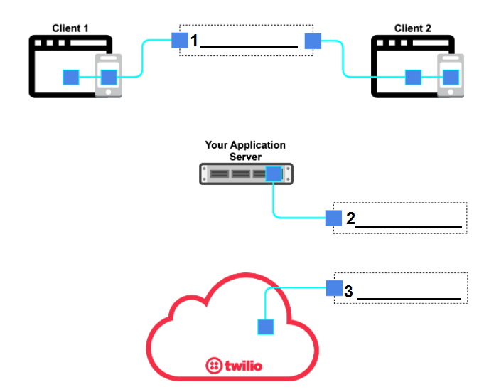

**Worksheet 4.5.5**

**Self-evaluation**

**Complete the following self-evaluation section.**

1. Entiendo qué es Twilio y cómo funciona.

**Yes 😃 Maybe 😐 No 😟**

2. Entiendo cómo hacer un organizador gráfico de un proceso.

**Yes 😃 Maybe 😐 No 😟**

3. Un organizador gráfico me ayuda a entender un proceso mejor.

**Yes 😃 Maybe 😐 No 😟**